**CLOUD BIGTABLE**

**NO SQL DATABASE SERVICE**

NO SQL :-  Not Only SQL

TYPES : Document database, key-value db, wide column , graph

**ARCHITECTURE**

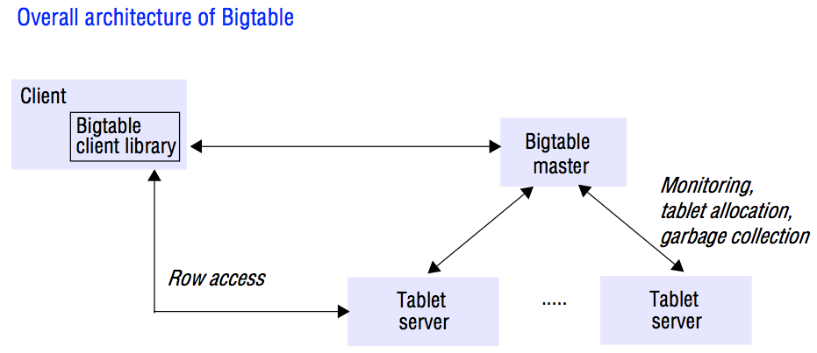

**LOCATION**

There is a file called Google File System and that is where it is stored.

**ADVANTAGES**

High reading

Fast throughput

If you wanna increase QPS, add nodes

Low Latency

Group of nodes to clusters and in instances

In instances, it is stored in SSD or HHD.

The type of storage your computer uses matters for performance, including power usage and reliability. **Solid state drives** (**SSDs**) and hard disk drives (HDDs) are the two main storage options to consider and it's important to know the best use for each and how they compare side by side.

SSD - Solid state drive is used instead of flash based memory(non-volatile in PC having access to delete and add data between PC and digital technologies)

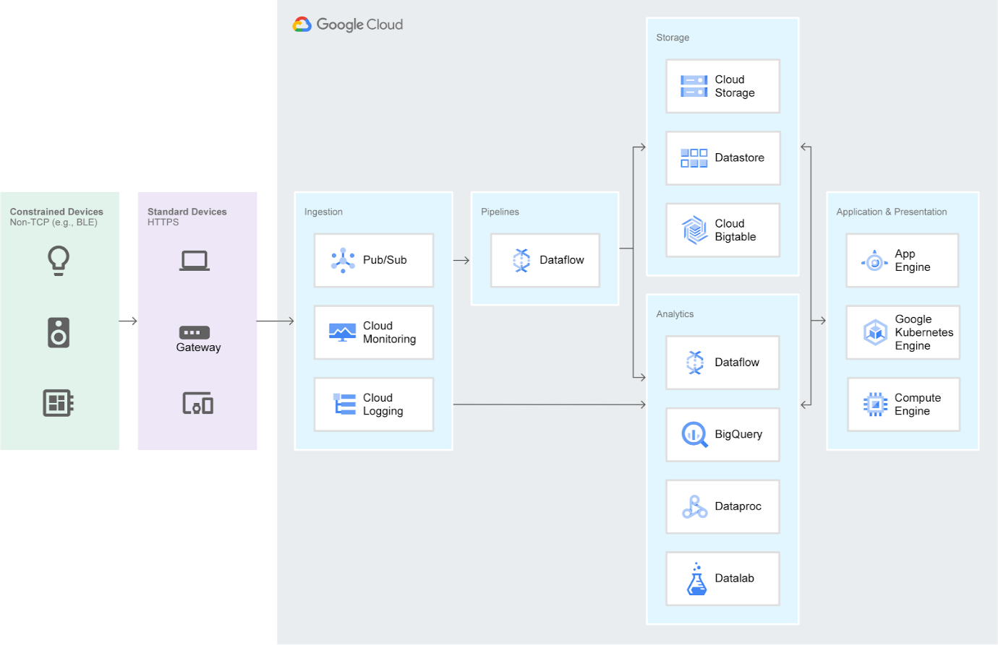

**CASSANDRA vs CLOUD BIGTABLE**

Partitioning is automatic in Cassandra

Fast and Accuracy

Easy understandable

RECENT UPDATES - HBASE to Cloud Big Data

REASON : SSD

IMPLEMENTATION STEPS :

USING CBT : <https://cloud.google.com/bigtable/docs/quickstart-cbt>

USING HBASE : <https://cloud.google.com/bigtable/docs/quickstart-hbase>

<https://codelabs.developers.google.com/codelabs/cbt-for-cassandra/index.html?_ga=2.8326198.566053094.1592972868-1625183988.1591688964#0>

CASSANDRA WITH BIGTABLE: <https://cloud.google.com/solutions/migration/hadoop/hadoop-gcp-migration-data-hbase-to-bigtable>